Lab 02 – Worksheet

Name: Faaz Shahab, Mohib Ul Mehdi | ID: fs09911, mm09730 | Section: T2

Note: Assumptions and logics should be explained separately in tasks after the task results.

Task 1.

Provide appropriately commented codes (Mention question part before each part)
Listing 1:

Instruction: bne x22, x23, Else
Machine hex code: 0x017B1663
32-bit binary: 00000001011110110001011001100011

the immediate field extracted from the binary to get PC offset of +12 bytes. This offset matches the value shown by Venus in place of the label Else.

Instruction: beq x0, x0, Exit
Machine hex code: 0x00000463
32-bit binary: 00000000000000000000010001100011

After decoding the SB-format immediate field, the calculated offset is +8 bytes, which matches the offset displayed by Venus for the label Exit.

Listing 2:

Instruction: bne x9, x24, Exit
Machine hex code: 0x01849663
32-bit binary: 00000001100001001001011001100011

The immediate field extracted from the SB-format instruction gives an offset of +12 bytes. This matches the offset shown by Venus after replacing the label Exit.

Instruction: beq x0, x0, Loop
Machine hex code: 0xFE0006E3
32-bit binary: 11111110000000000000011011100011

This is a backward branch. The extracted immediate field, when sign-extended, gives a PC-relative offset of −20 bytes, which matches the offset value shown by Venus for the label Loop.

Instruction | Hex | 32-bit Binary | SB type imm (imm[12 | 10:5 | 4:1 | 11]) | PC Offset (bytes)
bne x22, x23, Else | 0x017B1663 | 00000001011110110001011001100011 | imm[12]=0, imm[10:5]=000000, imm[4:1]=0110, imm[11]=0 | +12
beq x0, x0, Exit | 0x00000463 | 00000000000000000000010001100011 | imm[12]=0, imm[10:5]=000000, imm[4:1]=0100, imm[11]=0 | +8
bne x9, x24, Exit | 0x01849663 | 00000001100001001001011001100011 | imm[12]=0, imm[10:5]=000000, imm[4:1]=0110, imm[11]=0 | +12
beq x0, x0, Loop | 0xFE0006E3 | 11111110000000000000011011100011 | imm[12]=1, imm[10:5]=111111, imm[4:1]=0110, imm[11]=1 | -20

Add screenshot of your results (register)
Listing 1:
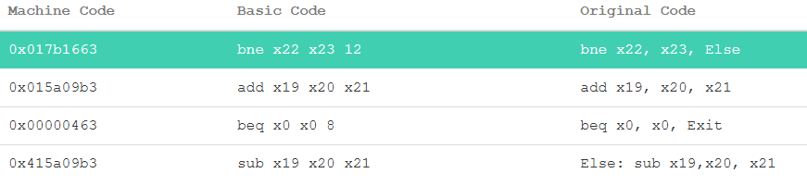
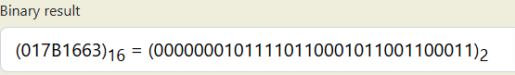
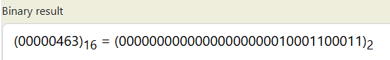

Listing 2:
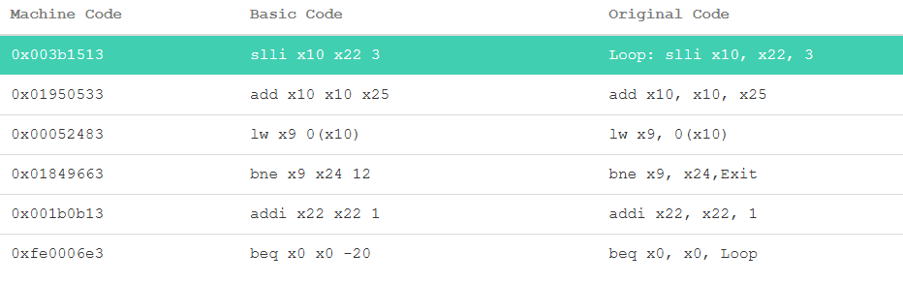
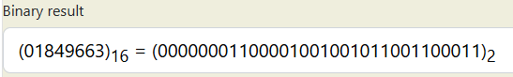
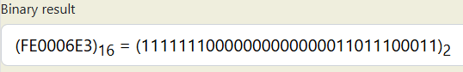

Task 2.

Provide appropriately commented codes (Mention question part before each part)
# To Run: setting x = 1 will give 10 + 8 = 18 in x21
addi x20, x0, 3

# Main code
addi x22, x0, 8 # b = 8
addi x23, x0, 10 # c = 10

addi x5, x0, 1 # temp1 = 1
addi x6, x0, 2 # temp2 = 2
addi x7, x0, 3 # temp3 = 3
addi x28, x0, 4 # temp4 = 4

beq x20, x5, case1
beq x20, x6, case2
beq x20, x7, case3
beq x20, x28, case4
beq x0, x0, default

# All Cases
case1:
add x21, x22, x23
beq x0, x0, end

case2:
sub x21, x22, x23
beq x0, x0, end

case3:
mul x21, x22, x6
beq x0, x0, end

case4:
div x21, x22, x6
beq x0, x0, end

default:
addi x21, x0, 0

end:

Add screenshot of your results (register)
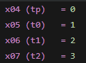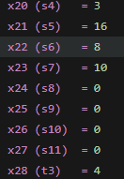

Task 3 Provide appropriately commented codes (Mention question part before each part)
addi x22, x0, 0 # i = 0
addi x23, x0, 0 # sum = 0
addi x5, x0, 10 #temp1 = 10 for checking loop end
addi x6, x0, 0 # newi = 0 computes newi = 4(i)
sw x21, 0x200(x0)

Loop1:
beq x22, x5, Initialize
sw x22, 0x200(x6)
addi x6, x6, 4
addi x22, x22, 1
beq x0, x0, Loop1

Initialize:
addi x22, x0, 0
addi x6, x0, 0

Loop2:
beq x22, x5, end
lw x28, 0x200(x6)
add x23, x23, x28
addi x22, x22, 1
addi x6, x6, 4
beq x0, x0, Loop2

end:
j end

Add screenshots of your results (register & memory both)
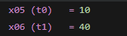
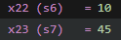
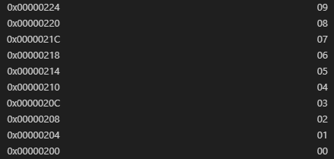

Task 4 (Challenge)

Provide appropriately commented codes (Mention question part before each part)

Add screenshots of your results (register & memory both)

Assessment Rubric
Lab 02: Implementing Decision Instructions in RISC – V Assembly Language

Task No. | LR 2  Code | LR 5  Results
Task 1 | /0 | /5
Task 2 | /10 | /10
Task 3 | /15 | /10
Task 4 | /20 | /10
Total Points: 100 | /45 | /35
CLO Mapped | CLO 2

Affective Domain | Rubric | Points | CLO Mapped
AR7 | Report Submission & Git Upload | /10 & /10 | CLO2

CLO | Total Points | Points Obtained
2 | 100
Total | 100

For description of different levels of the mapped rubrics, please refer to the Lab Evaluation Assessment Rubrics and Affective Domain Assessment Rubrics provided here.

Lab Evaluation Assessment Rubric
# | Assessment Elements | Level 1: Unsatisfactory | Level 2: Developing | Level 3: Good | Level 4: Exemplary
LR2 | Program/Co de/ Simulation Model/ Network Model | Program/code/simulation model/network model does not implement the required functionality and has several errors. The student is not able to utilize even the basic tools of the software. | Program/code/simulation model/network model has some errors and does not produce completely accurate results. Student has limited command on the basic tools of the software. | Program/code/simulation model/network model gives correct output but not efficiently implemented or implemented by computationally complex routine. | Program/code/simulation  /network model is efficiently implemented and gives correct output. Student has full command on the basic tools of the software.
LR5 | Results & Plots | Figures/ graphs / tables are not developed or are poorly constructed with erroneous results. Titles, captions, units are not mentioned.  Data is presented in an obscure manner. | Figures, graphs and tables are drawn but contain errors. Titles, captions, units are not accurate. Data presentation is not too clear. | All figures, graphs, tables are correctly drawn but contain minor errors or some of the details are missing. | Figures / graphs / tables are correctly drawn and appropriate titles/captions and proper units are mentioned. Data presentation is systematic.
AR9 | Report Content/Code Comments | No summary provided. The number/amount of tasks completed below the level of satisfaction and/or submitted late | Couldn’t provide good summary of in-lab tasks. Some major tasks were completed but not explained well.  Submission on time. Some major plots and figures provided | Good summary of In-lab tasks. All major tasks completed except few minor ones. The work is supported by some decent explanations, Submission on time, All necessary plots, and figures provided | Outstanding Summary of In-Lab tasks. All task completed and explained well, submitted on time, good presentation of plots and figure with proper label, titles and captions

